**SUPPLEMENTARY MATERIAL**

**ESVAC Antibiotic Sales Data Scaling**

European Surveillance of Veterinary Antimicrobial Consumption (ESVAC) antibiotic sales data was used in this study as a proxy for livestock antibiotic usage (**reference**). This measure was used due to a lack of livestock species-specific antibiotic usage surveillance data stratified by country. We note that livestock antibiotic sales are not an exact proxy measure for usage, nor has a definitive link been proven between these two quantities. However, due to a lack of more relevant epidemiological surveillance data, the ESVAC dataset was deemed sufficient.

The ESVAC dataset provides antibiotic sales expressed in mg/PCU for all livestock, representing a composite measure of milligram (mg) of active ingredient normalised by the population correction unit (PCU). This latter measure, PCU, can be considered the total biomass of all livestock populations potentially treatable with antimicrobials. A scaling calculation was conducted to scale the non-specific overall livestock antibiotic sales to be species-specific for each case study.

This scaling was performed by first identifying the proportion PCU of the particular livestock species of interest in each case study, in relation to the total livestock PCU in each country. This country-specific proportion was then used to scale the level of antibiotic usage (mg/PCU) for the specific livestock species of interest for each country. This was repeated for every included year for each country in each case study. Note that for this study, g/PCU was used as the antibiotic sales unit of measurement for all model fitting. An example of this scaling calculation using the average across each considered country in the dataset for each case study can be found below (countries with n > 10 samples) (Table S1).

**Table S1. Scaling for species-specific antibiotic sales using the averages across included countries/years as illustrative example.**

|  |  |  |  |  |  |  |  |
| --- | --- | --- | --- | --- | --- | --- | --- |
| Case Study | Livestock Species | Antibiotic Resistance | Total PCU | Livestock-specific PCU | Fraction of the country PCU | Country level Antibiotic Sales  (mg/PCU) | Scaled Antibiotic Sales  (mg/PCU) |
| **1 (n = 69)** | Broiler Poultry | Ampicillin | 2676.90 | 2134.717 | 0.142828 | 24.46256 | 3.493929 |
| **2 (n = 69)** | Broiler Poultry | Tetracycline | 2676.90 | 2134.717 | 0.142828 | 34.02772 | 4.860097 |
| **3 (n = 37)** | Fattening Pigs | Ampicillin | 2134.86 | 693.0439 | 0.324632 | 25.07895 | 8.14143 |
| **4 (n = 37)** | Fattening Pigs | Tetracycline | 2134.86 | 693.0439 | 0.324632 | 33.45789 | 10.8615 |

The final scaled measure is therefore the country-level antibiotic sales scaled by the livestock-specific biomass and not necessarily the livestock-specific level of antibiotic usage for each country. However, in lieu of more accurate antibiotic usage surveillance data, this proxy measure was used in the model fitting process.

**Community-level scaling for the overall prevalence of human salmonellosis**

Access to surveillance data for human non-typhoidal salmonellosis is available through the European Centres for Disease Control (ECDC) annual epidemiological reports (**reference**). However, factors such as under-ascertainment (health seeking behaviour) and underreporting of non-typhoidal salmonellosis will likely result in the reported incidence being an underestimate of community-level transmission. Use of multiplication factors have been proposed, which uses a scaling factor to upscale incidence rates in surveillance reports to more accurately reflect community-level incidence (**reference**). We aimed to capture this community-level rather than the reported incidence of non-typhoidal salmonellosis for use in this study.

Data from the Burden of Communicable Disease in Europe (BCoDE) study was used to obtain an estimate for the average community incidence of non-typhoidal salmonellosis in EU/EEA countries (**reference**). The BCoDE study was undertaken from 2009-2013, occupying a different timeframe from the resistance data used in the ABC-SMC model fitting (2014-2018) (**reference**). However, due to a recent plateau in the absolute incidence of non-typhoidal salmonellosis over the last decade, we assumed that this BCoDE data could be extrapolated to the more recent timeframe of the resistance data (**PLOT**). This is barring any extensive European demographic changes over the last decade (denominator) which would alter the incidence per unit population.

From the BCoDE data, an annual community-level incidence of 216.46 per 100,000 was identified for non-typhoidal salmonellosis averaged across sex and age groups. To convert this estimate into a daily incidence usable in this study, this annual incidence was divided by. (**reference**)(**reference for calculation**). This resulted in a European community-level estimate for the daily incidence of 0.593 per 100,000 population. This was used as the model baseline for the overall daily incidence of human non-typhoidal salmonellosis in Europe under current livestock antibiotic usage levels.

**Fourier Amplitude Sensitivity Test analyses**

The Fourier amplitude sensitivity test (FAST) is a variance-based sensitivity analysis that partitions variance in the model output to variation in the model parameters. It does so through the calculation of Fourier coefficients at different frequencies corresponding to the identify of unique model parameters. We explored the sensitivity of two main outcome measures to the model parameters (with regards to livestock antibiotic curtailment):

1. *Relative changes* *in the daily incidence when livestock antibiotics are curtailed (τ = 0 g/PCU), compared to the daily incidence at the baseline livestock antibiotic usage (τ =* 0.00934  *g/PCU).*

The purpose of this outcome measure was to identify parameters (excluding τ) which have the greatest influence on relative changes in the daily incidence when livestock antibiotics are curtailed from baseline levels (τ = 0.00934→ 0 g/PCU). We note that this outcome measure allows for the baseline level of the daily incidence to change with each combination of parameters from the Fourier sampling algorithm, with each scenario possessing a unique baseline level of the daily incidence at τ = 0.00934g/pCU, with alterations to other model parameters reflecting a new location/drug/bug livestock host scenario or case study. By assuming this flexible baseline level of the daily incidence, we can explore parameters or scenarios which will result in the greatest relative change in daily incidence when livestock antibiotics are curtailed (*τ* = 0 g/PCU). The baseline level of livestock antibiotic usage was fixed at τ = 0.00934g/PCU to facilitate the comparison of outcome measures across the different parameter combinations. The outcome measure is formally defined as: daily incidence at τ = 0 / daily incidence at τ = 0.00934.

1. *Relative changes in daily incidence when livestock antibiotics were curtailed (τ = 0 g/ PCU), compared to daily incidence of 0.593 per 100,000 population.*

This outcome measure allows for the identification of parameters (excluding τ) which can best control increases in daily incidence upon livestock antibiotic curtailment (*τ* = 0 g/PCU). This is similar to the previous outcome measure, but with the daily incidence at baseline livestock usage fixed to 0.593 per 100,000 population, representing the baseline level of daily incidence for the four considered case studies. This fixed value can be considered a threshold of daily incidence that would be undesirable to exceed, due to this being the current levels of daily incidence observed at baseline livestock antibiotic usage levels (*τ* = 0.00934 g/PCU). By fixing the daily incidence and identifying relative variation from this “threshold” value, we can identify parameters that result in the greatest change from this threshold, and by extension parameters which can best control or prevent increases in the daily incidence beyond what we already observe with livestock antibiotic usage. The outcome measure is formally defined as: daily incidence at τ = 0 g/PCU / 0.593 per 100,000.

**Model Comparison and ζ Parameter**

We note that the addition of the ζ parameter was done to prevent the fraction of antibiotic-resistant human infection (I*­RHProp) descreasing to 0 upon total curtailment of livestock antibiotic (τ = 0.00934→ 0 g/PCU). Using the ABC-SMC framework, we can undertake a formal comparison to identify if the addition of this ζ parameter performs better than the nested null hypothesis model where ζ = 0, and I*­RHProp is initiated at the origin when livestock antibiotic usage is curtailed (Toni et al, 2009).

We define a new parameter describing the model choice, with and and corresponding to the ODEs described in **1.31**, where in and in , and with is nested within . We note that the overall aim of the model selection approach identified in Toni et al, 2009, is to provide an approximation of the marginal posterior distribution of the parameter given the data, . Model specific parameter vectors are then created, , with only the fitted parameters represented: and . The prior distributions used in the model comparison approach is identical to those used to fit the model parameters (**Table X**), with a discrete uniform distribution limited at 1 and 2, used for the model selection parameter, . The model comparison algorithm is detailed in Toni et al, 2009.

This Bayes factor is a summary of the evidence for one model over the other given the data. We can recover the equation for the Bayes factor through an odds transformation of the marginal posterior probability of given the data and given the data (Kass et al).

With the Bayes factor, , being:

If we assume that the prior distribtions for and are uniform, then we can cancel the last multiplicative term in eqn **XXX**, and therefore we recover the equation for by substituting eqn **XXX** in eqn **XXX**.

The Bayes factor is therefore a ratio of the posterior probability of given the data and given the data. As the ABC-SMC algorithm returns an approximation of the marginal posterior distribution of the and , and , we can simply take a ratio of the number of accepted particles for each model in the last generation. This represents the model with the highest posterior probability. This is therefore an approximation of the Bayes factor and allows for model selection. Therefore, we denote the model with the greatest number of accepted particles in the last generation, the best fitting model. We run the model fitting process until 10 generations of 1000 accepted particles, or until one model is the sole model structure chosen. As stated in Toni et al, 2009, the model selection algorithm implicitely penalizes models with a large number of parameters, as models with a larger parameter dimension have a smaller probability of being accepted.

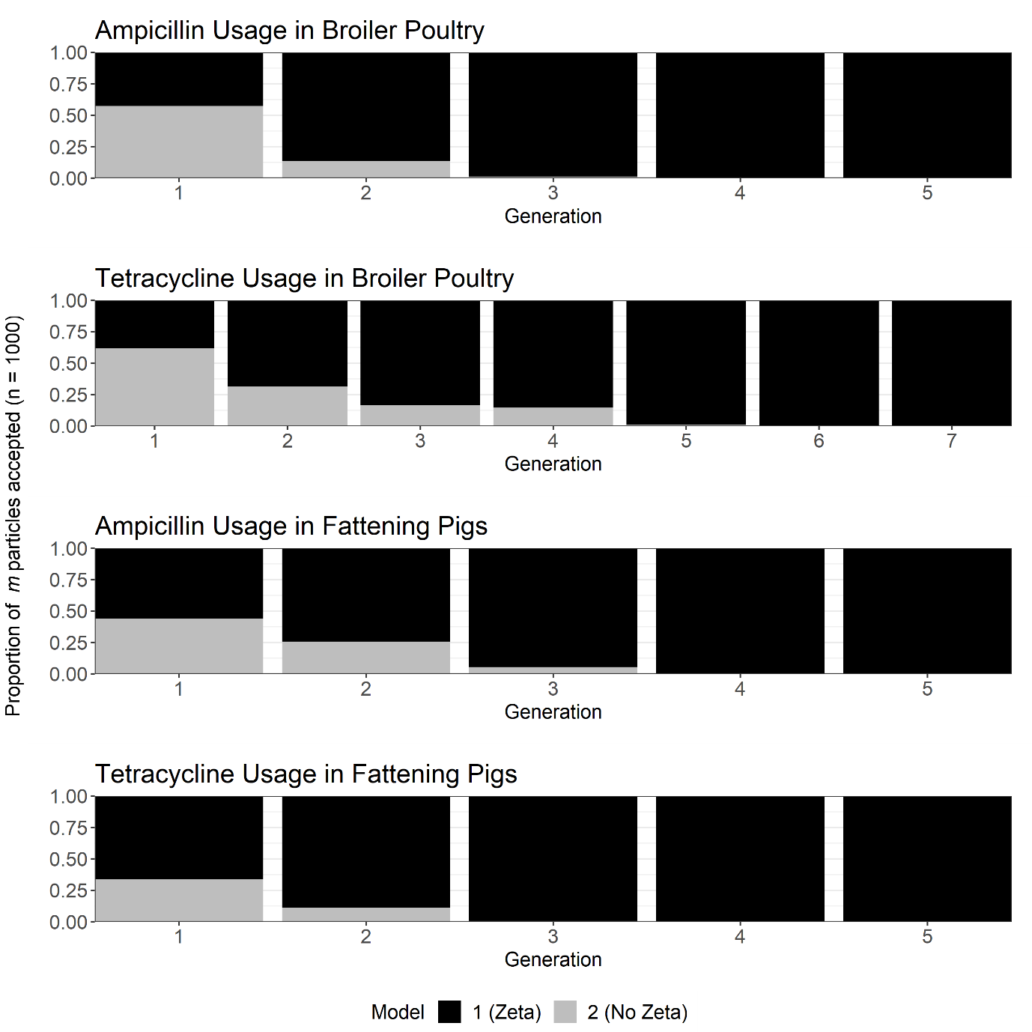

**Figure S1**. Ratio of the accepted particles for and , across all generations of the ABC-SMC model selction for the ampicillin usage in broiler poultry, tetracycine usage in broiler poultry, tetracycline usage in fattening pigs and ampicillin usage in fattening pigs case studies.

We find that all case studies result in a model “die-out” with model 1 () being the sole selected model in the last generation. It was interesting to note that in the initial generations for the broiler poultry case studies, model selection favored , settling on as reaches the final posterior distribution. As described in Toni et al, 2009, this is likely due to the selection algorithm passing a local maximum favoring on the way to .

**Software Used**

All simulations were carried out using R and RStudio. R package “rootSolve” was used for all model simulations. All sensitivity analyses were performed using the FAST and sensitivity R packages (**CITE**). The ABC-SMC approach used “tmvtnorm” and “bayestestR” packages. Plotting used “ggplot2”, “ggpubr”, “metR”, “grid and “gridExtra” R packages.

**Model Equations**

**Table S2. Parameter values for case study models**

|  |  |  |  |  |  |  |
| --- | --- | --- | --- | --- | --- | --- |
| Parameter | Description | Case Study (Fitted) Parameter Values  (Sum of squares from model fit in brackets) | | | | References |
| **Ampicillin resistance in Broiler Poultry**  **(SS = 1.2843)** | **Tetracycline resistance in Broiler Poultry**  **(SS = 1.2843)** | **Ampicillin resistance in Fattening Pigs**  **(SS = 0.5111)** | **Tetracycline resistance in Fattening Pigs**  **(SS = 0.5684)** |
| ***βAA*** | Per Capita Rate of Transmission (Direct and Indirect) between the Infected Animal Fraction and Susceptible Animal Fraction | **0.009307**  **[0.000004,**  **0.0222002] 1** | **0.009307**  **[0.000004,**  **0.0222002] 1** | **0.02444**  **[0.0006,**  **0.053487] 1** | **0.03893**  **[0.00009,**  **0.099698]1** | [19, 24] |
| ***βHH*** | Per Capita Rate of Transmission (Direct and Indirect) between the Infected Human Fraction and Susceptible Human Fraction | 0.00001 | 0.00001 | 0.00001 | 0.00001 | N/A |
| ***βAH*** | Per Capita Rate of Transmission (Direct and Indirect) from the Infected Human Fraction to the Susceptible Animal Fraction | 0.00001 | 0.00001 | 0.00001 | 0.00001 | N/A |
| ***βHA*** | Per Capita Rate of Transmission (Direct and Indirect) from the Infected Animal Fraction to the Susceptible Human Fraction |  |  |  |  | N/A |
| ***ζ*** | Background rate of transmission of foodborne bacteria to the livestock population | **0.02703**  **[0.00184,**  **0.035986] 1** | **0.02703**  **[0.00184,**  **0.035986] 1** | **0.05279**  **[0.020654,**  **0.083811] 1** | **0.04126**  **[0.01149,**  **0.087397] 1** | N/A |
| ***τ*** | Per Capita Rate of Antibiotic Usage in Livestock (Baseline) in g/PCU | 0.0067 | 0.0067 | 0.0116 | 0.0123 | N/A |
| *κ* | Efficacy of antibiotic-mediated livestock recovery. | **0.75909**  **[0.00858,**  **1.54925] 1** | **0.75909**  **[0.00858,**  **1.54925] 1** | **1.73333**  **[0.399002,**  **2.97116] 1** | **1.93543**  **[0.49021,**  **2.99175] 1** | N/A |
| ***α*** | Transmission-related fitness costs associated with antibiotic-resistant strains (relative to antibiotic-sensitive strains). | **0.26406**  **[0.175553,**  **0.348345] 1** | **0.26406**  **[0.175553,**  **0.348345] 1** | **0.443335**  **[0.330823,**  **0.574107] 1** | **0.33559**  **[0.12856,**  **0.56843] 1** | **Davies et al, 2019** |
| ***φ*** | Per Capita Rate of Conversion from antibiotic-resistant to antibiotic-sensitive infection in animals | **0.017127**  **[0.0103176,**  **0.023423] 1** | **0.017127**  **[0.0103176,**  **0.023423] 1** | **0.018479**  **[0.00781,**  **0.03138] 1** | **0.023856**  **[0.000602,**  **0.043209] 1** | N/A |
| ***rA*** | Per Capita Rate of Natural Recovery from Animal Infection | 0 days-1 | 0 days-1 | 60 days-1 | 60 days-1 | [27]ref |
| ***rH*** | Per Capita Rate of Natural Recovery from Human Infection | 5.5 days-1 | 5.5 days-1 | 5.5 days-1 | 5.5 days-1 | [17] |
| ***µA*** | Per Capita Birth/Death Rate in Animals | 42 days-1 | 42 days-1 | 240 days-1 | 240 days-1 | [28]ref |
| ***µH*** | Per Capita Birth/Death Rate in Humans | 28835 days-1 | 28835 days-1 | 28835 days-1 | 28835 days-1 | [29] |

1Note that values in bold are mean point estimates from the posterior distribution of fitted parameters, lower and upper bounds of the 95% HDI are shown in square brackets.

**Table S3. Prior distributions used for ABC-SMC model fitting**

|  |  |  |  |
| --- | --- | --- | --- |
| Parameter | Description | Prior Distribution | References |
| **βAA** | Per Capita Rate of Transmission (Direct and Indirect) between the Infected Animal Fraction and Susceptible Animal Fraction |  | [19, 24] |
| **κ** | Scaling parameter to model uncertainty in the effects of antibiotic treatment (τ) on the per capita rate of antibiotic-resistant to antibiotic-sensitive conversion. |  | N/A |
| **φ** | Per Capita Rate of Conversion from Antibiotic-Resistant to Antibiotic-Sensitive Infection in Animals |  | N/A |
| **α** | Transmission-related fitness costs associated with antibiotic-resistance |  | **Davies et al, 2019** |
| **ζ** | Background rate of transmission of foodborne bacteria to the livestock population |  | N/A |
| **βHA** | Per Capita Rate of Transmission (Direct and Indirect) between the Infected Animal Fraction and Susceptible Human Fraction |  | N/A |

**Table S4. ε thresholds used for each of the five generations for the ABC-SMC model fitting.**

|  |  |  |  |  |  |  |  |  |  |  |  |  |
| --- | --- | --- | --- | --- | --- | --- | --- | --- | --- | --- | --- | --- |
| Summary Statistics | Case Study | Generation | | | | | | | | | | |
| **1** | **2** | **3** | **4** | **5** | **6** | **7** | **8** | **9** | **10** |
| Sum of squared errors | Ampicillin resistance in Broiler Poultry | 4 | 3 | 2.5 | 2 | 1.8 | 1.6 | 1.5 | 1.4 | 1.35 | 1.3 |
| Tetracycline resistance in Broiler Poultry | 4 | 3 | 2.5 | 2 | 1.8 | 1.6 | 1.5 | 1.4 | 1.35 | 1.3 |
| Ampicillin resistance in Fattening Pigs |  |  |  |  |  |  |  |  |  |  |
| Tetracycline resistance in Fattening Pigs | 2.5 | 2 | 1.75 | 1.5 | 1.25 | 1 | 0.9 | 0.8 | 0.75 | 0.7 |
| Difference between modelled and observed overall prevalence of human salmonellosis | Ampicillin resistance in Broiler Poultry | 0.82 | 0.65 | 0.57 | 0.49 | 0.41 | 0.33 | 0.26 | 0.20 | 0.13 | 0.11 |
| Tetracycline resistance in Broiler Poultry | 0.82 | 0.65 | 0.49 | 0.41 | 0.33 | 0.25 | 0.16 | 0.1 | 0.03 | 0.02 |
| Ampicillin resistance in Fattening Pigs | 1.14 | 0.81 | 0.65 | 0.49 | 0.33 | 0.25 | 0.16 | 0.08 | 0.03 | 0.02 |
| Tetracycline resistance in Fattening Pigs |  |  |  |  |  |  |  |  |  |  |
| Difference between modelled and observed proportion of resistant human salmonellosis | Ampicillin resistance in Broiler Poultry | 0.09 | 0.07 | 0.06 | 0.05 | 0.04 | 0.035 | 0.028 | 0.021 | 0.014 | 0.01225 |
| Tetracycline resistance in Broiler Poultry | 0.08 | 0.06 | 0.05 | 0.04 | 0.03 | 0.02 | 0.015 | 0.01 | 0.003 | 0.001 |
| Ampicillin resistance in Fattening Pigs | 0.11 | 0.08 | 0.06 | 0.05 | 0.03 | 0.02 | 0.01 | 0.007 | 0.003 | 0.002 |
| Tetracycline resistance in Fattening Pigs |  |  |  |  |  |  |  |  |  |  |

**Supplementary Figures**

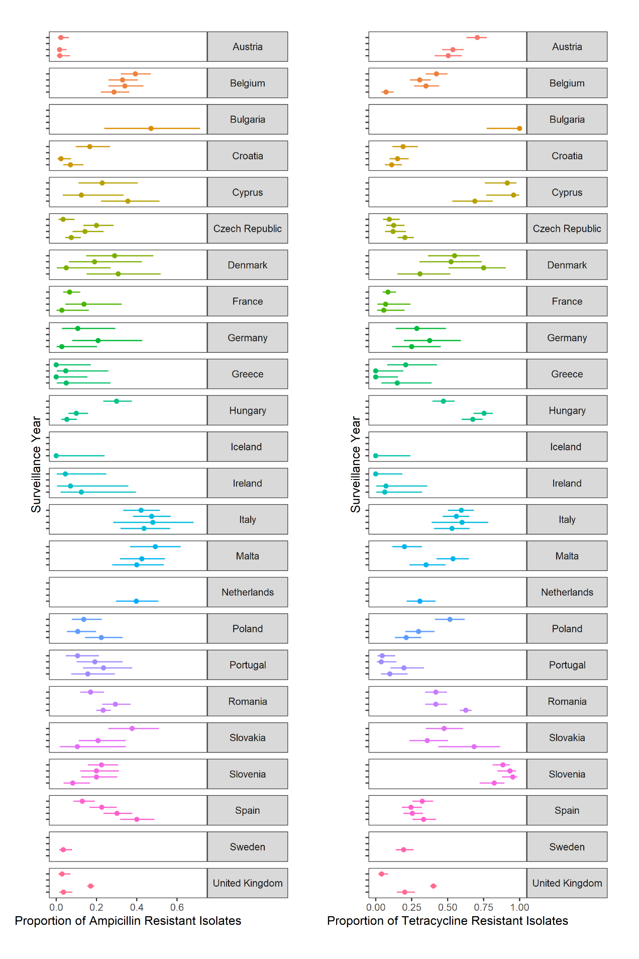

**Figure S2. Stability of ampicillin and tetracycline resistance during 2014-2018 across each country in the EFSA data set for broiler poultry.** Note that the unmarked Y-axis corresponds to 2014 (lowest) to 2018 (highest) for all countries.

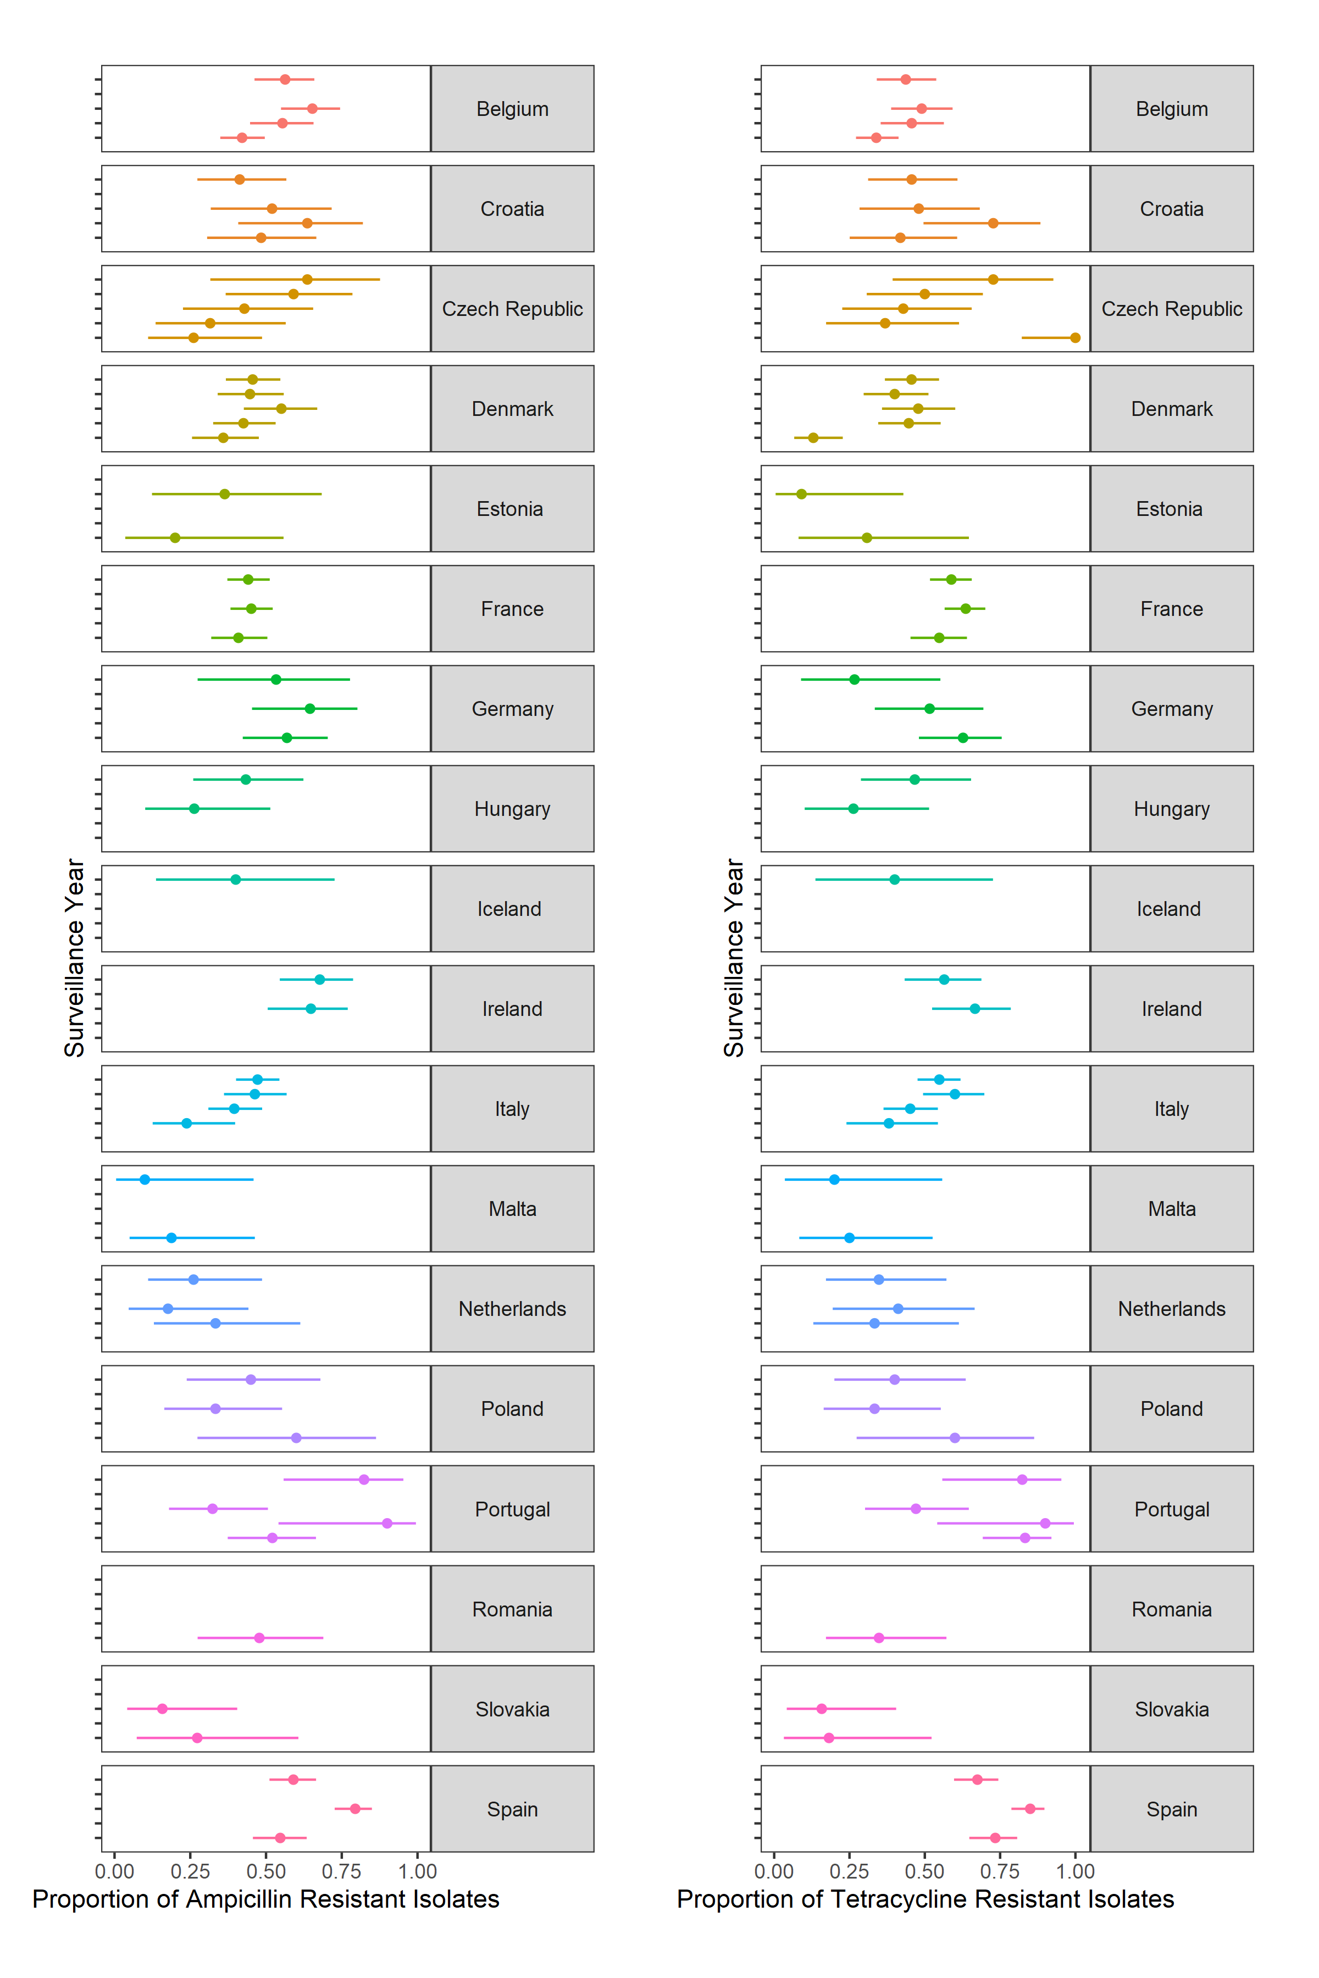

**Figure S3. Stability of ampicillin and tetracycline resistance during 2014-2019 across each country in the EFSA data set for fattening pigs.** Note that the unmarked Y-axis corresponds to 2014 (lowest) to 2019 (highest) for all countries.

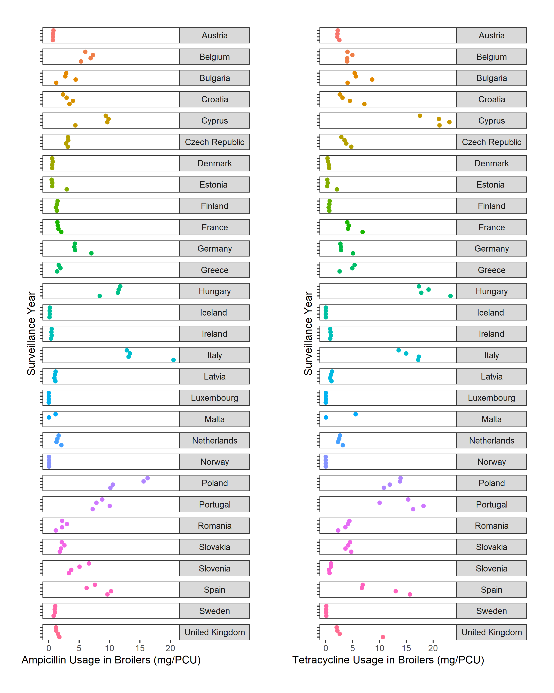

**Figure S4. Stability of ampicillin and tetracycline usage during 2014-2018 across each country in the ESVAC data set for broiler poultry.** Note that the unmarked Y-axis corresponds to 2014 (lowest) to 2018 (highest) for all countries.

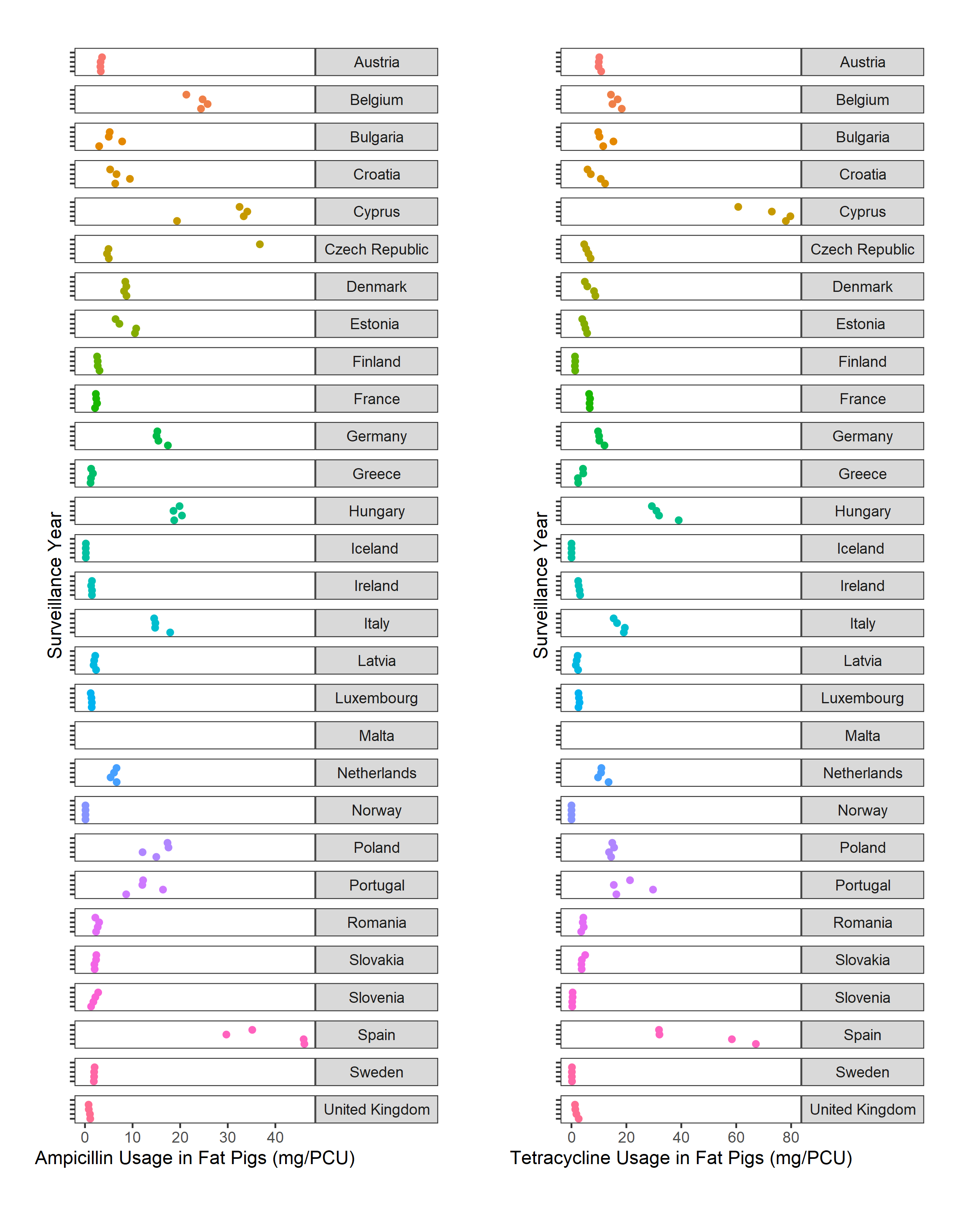

**Figure S5. Stability of ampicillin and tetracycline usage during 2014-2019 across each country in the ESVAC data set for fattening pigs.** Note that the unmarked Y-axis corresponds to 2014 (lowest) to 2019 (highest) for all countries.

**Figure S6. Estimated posterior distributions for the rate of animal-to-animal transmission (βAA), efficacy of antibiotic-mediated recovery (κ), rate of antibiotic-resistant to antibiotic-sensitive reversion (φ), transmission-related fitness costs of resistance (α), background rate of transmission to animal populations (ζ) and the rate of animal-to-human transmission (βHA).** A) Tetracycline usage in fattening pigs. B) Ampicillin usage in fattening pigs. C) Tetracycline usage in broiler poultry. The estimated posterior distribution for each generation is highlighted by fill colours. Red line represents the posterior mean from the 10th generation for each parameter.

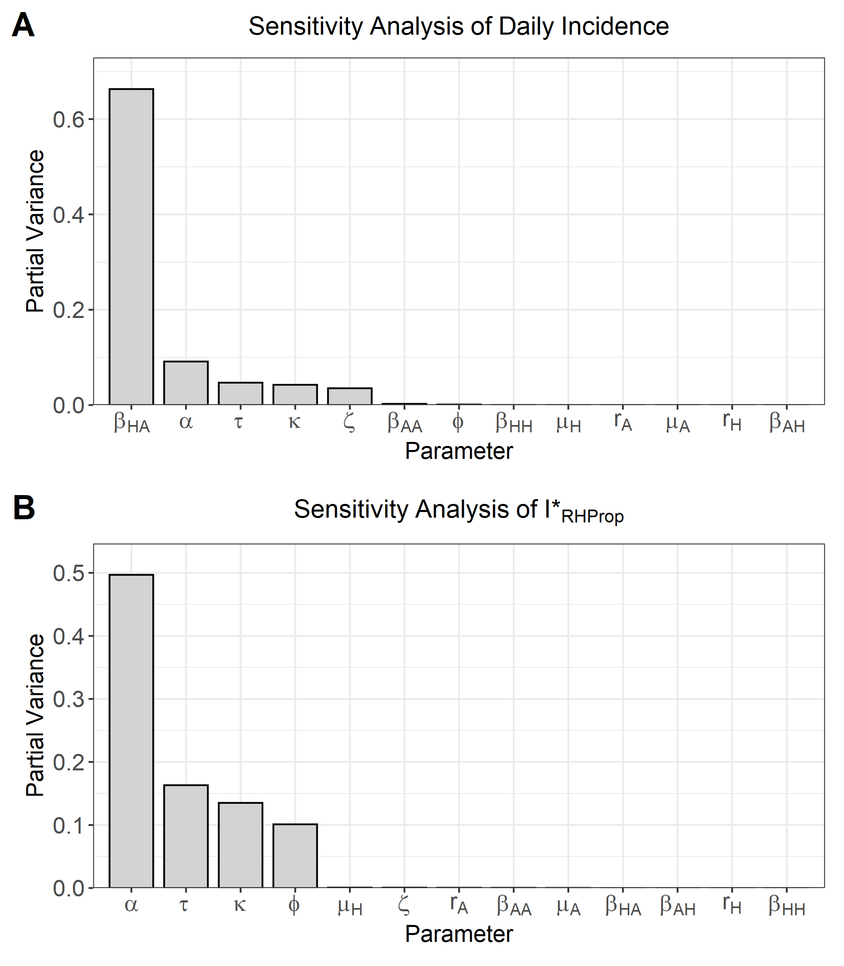

**Figure S7. Fourier amplitude senstivity test (FAST) to identify the most influential model parameter for: A) EU-averaged daily incidence of non-typhoidal salmonellosis. B) The fraction of antibiotic-resistant human non-typhoidal salmonellosis (I*­RHProp).** Parameters for each sensitivity analysis are ordered from left-to-right by the most influential model parameter (partial variance) for the respective analysis.

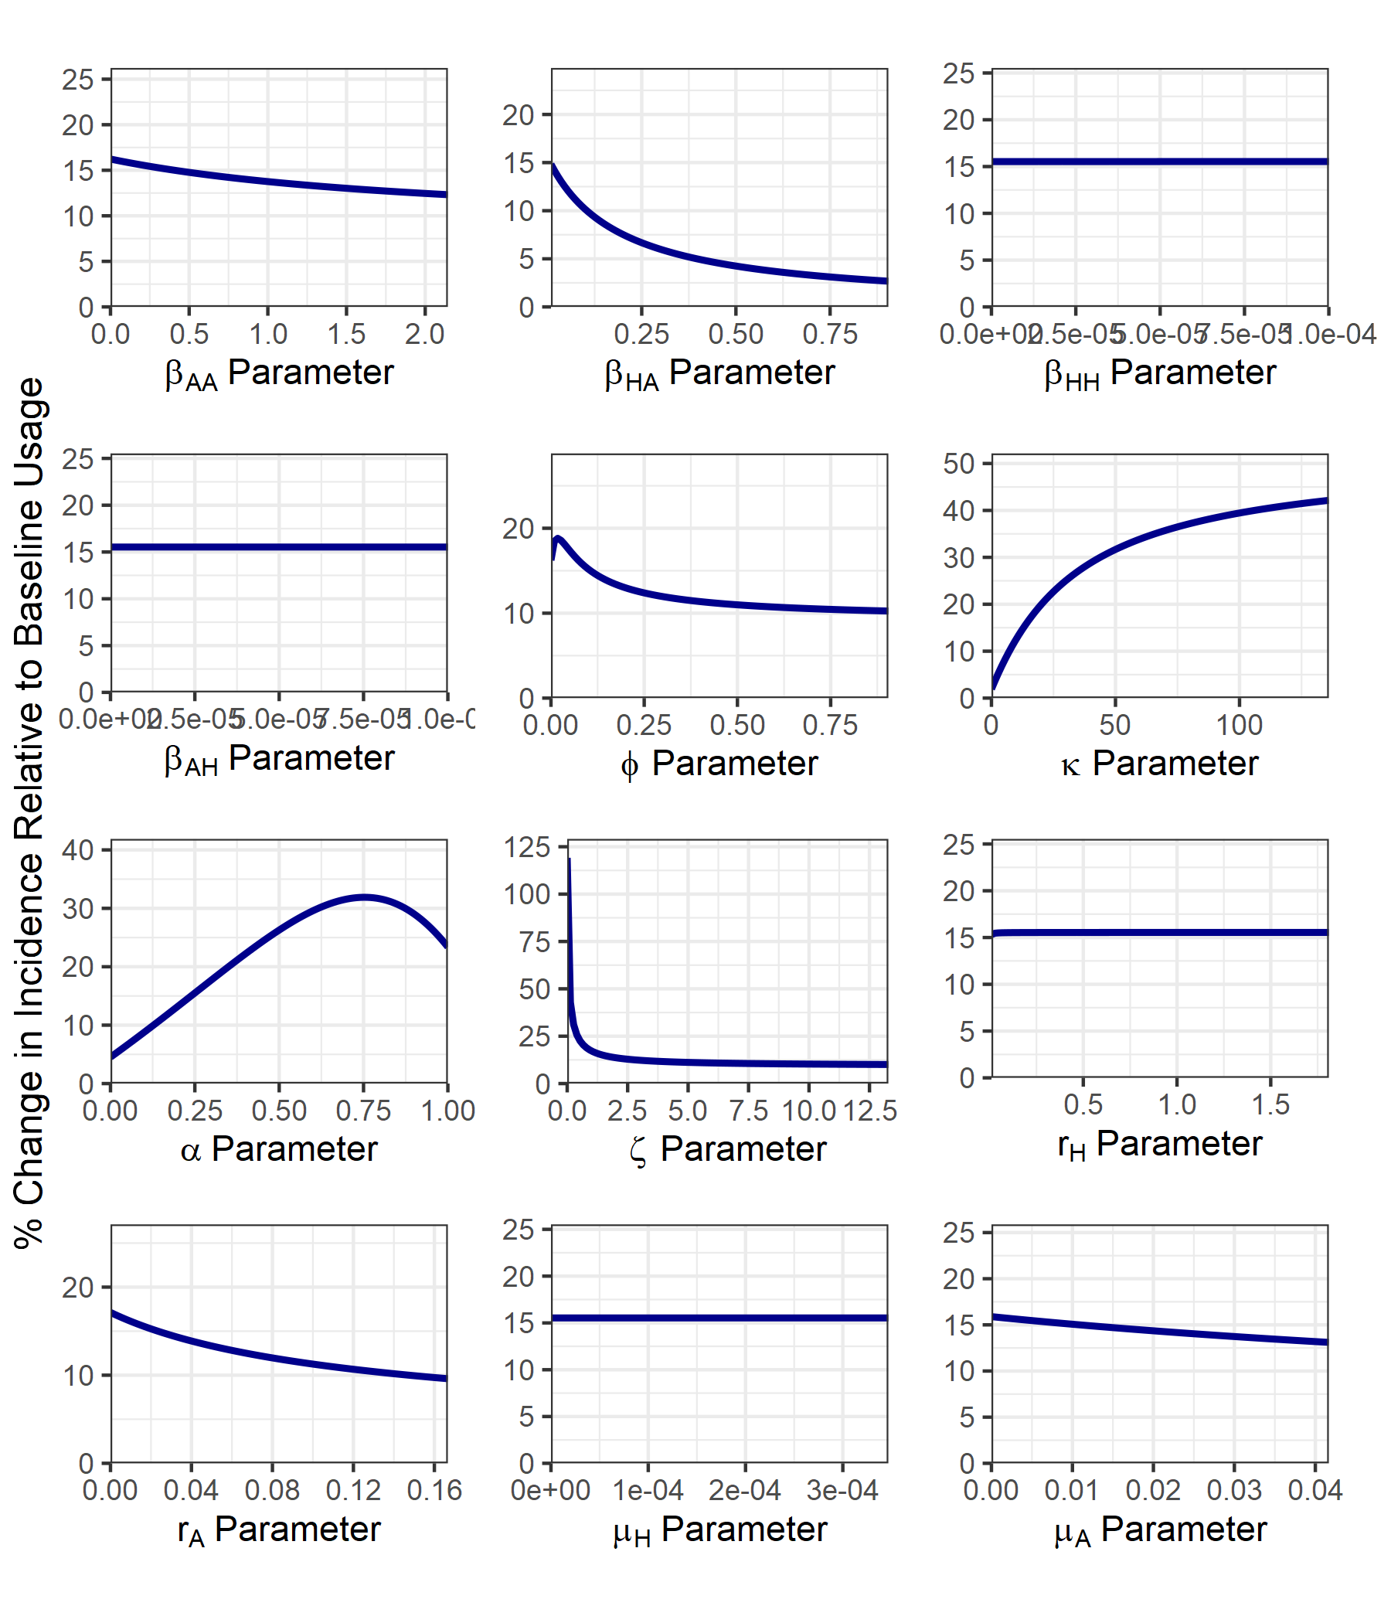

**Figure S8. Impact of varying each model parameter individually on the percentage change in ICombH under livestock antibiotic curtailment (τ = 0 g/PCU) relative to mean baseline livestock antibiotic usage across the four case studies (τ = 0.00934 g/PCU).** It is important to note that a % change can be interpreted as a relative increase or decrease relative to baseline daily incidence. The direction of the relative change is described in the main text. The explored parameter range for each parameter was bounded at 0 to an order of magnitude above the parameterised model value. An exception was for *rH*, with *rH* ∈ [0.01, 0.55-1] to prevent the large relative changes in daily incidence at *rH* = 0 obscuring presented results. For fitted parameter this was taken as an order of magnitude above the mean fitted parameter value across all four case studies.

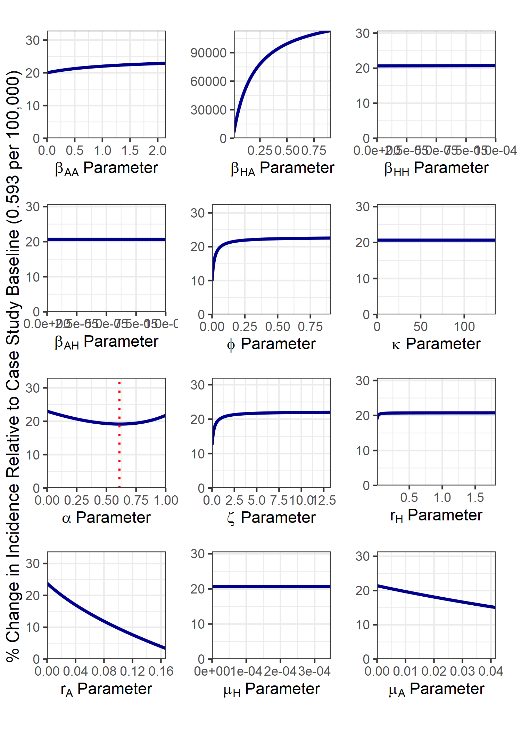

**Figure S9. Impact of varying each model parameter individually on the percentage change in daily incidence under livestock antibiotic curtailment (τ = 0 g/PCU) relative to the baseline daily incidence under current levels of antibiotic usage 0.593 per 100,000 population.** Note that the red, dotted line represents parameters which have both a relative increase and decrease in daily incidence from the baseline threshold of 0.593 per 100,000 population representing a non-monotonic relationship with the outcome measure. Note that the only non-monotonic relationship was found with α. The explored parameter range for each parameter was bounded at 0 to an order of magnitude above the parameterised model value. An exception was for *rH*, with *rH* ∈ [0.01, 0.55-1] to prevent the large relative changes in ICombH at *rH* = 0 obscuring presented results. For fitted parameter this was taken as an order of magnitude above the mean fitted parameter value across all four case studies.

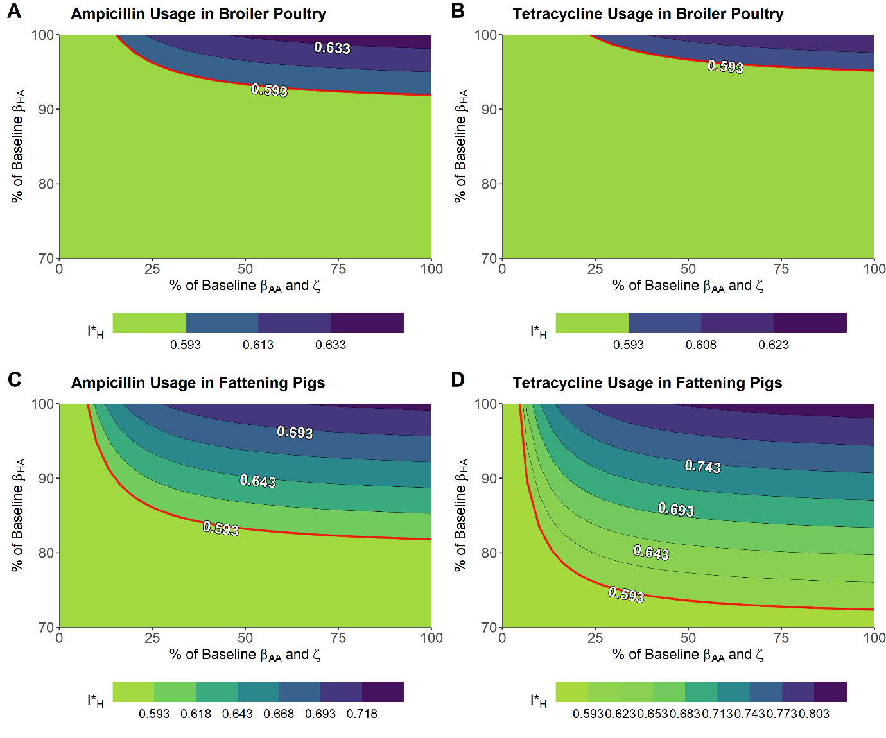

**Figure S10. Reductions to key model parameters, animal-to-human transmission (βHA), animal-to-animal transmission (βAA) and the background transmission rate to animal populations (ζ) to mitigate increases in the daily incidence of salmonellosis under livestock antibiotic curtailment (τ = 0 g/PCU). A) Ampicillin-resistance in broiler poultry, B) tetracycline-resistance in broiler poultry, C) ampicillin-resistance in fattening pigs and D) tetracycline-resistance in fattening pigs.** Axes represent interventions that reduce the labelled transmission rate(s) to % of their original values. Note that the top right corner of each contour plot represents a scenario with curtailment of antibiotics and no further alterations to any model parameter. The red line represents the threshold at which daily incidence is below current levels (0.593 per 100,000). Note the different axis compared to the original analysis (Figure 6), with the βAA/ζ transmission rates now changed from a 30% to a full 100% reduction.

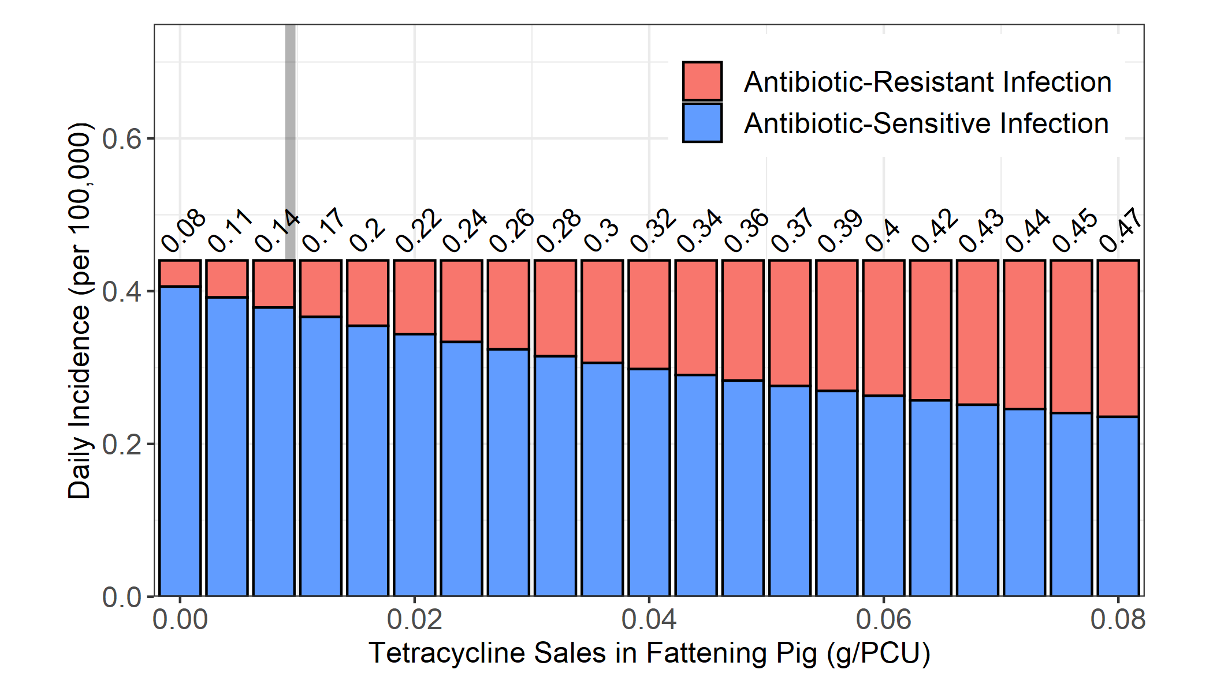

**Figure S11. Impact of alterations in livestock antibiotic sales (τ) on the daily incidence of salmonellosis and the proportion of resistant human infection (I*RHProp).** Grey line represents the averaged baseline antibiotic usage across all four case studies (0.00934 g/PCU) Parameters α and κ were set to 0 as an illustrative example. This represents a scenario where livestock antibiotics have no therapeutic effect in livestock and fitness costs of resistance have no effect on transmission. Reductions to livestock antibiotic usage now has no discernible effect on increasing human foodborne disease (τ).

**Supplementary References**